A
Project Report
AI Chatbot for Education System
on
Submitted in fulfilment of the award of the Bachelor of Technology
in

Department of Data Science
By
T. Sreesha(241UR3013)

G. Manasa (241U1R3001)

M. Mokshesh Goud (241U1R3014)

Under the esteemed guidance of

Mr. A. Rajeshwar Associate Professor


DEPARTMENT OF COMPUTER SCIENCE ENGINEERING SCHOOL OF ENGINEERING

AURORA HIGHER EDUCATION AND RESEARCH ACADEMY
(Deemed- to- be- University) Parvathapur, Uppal, Hyderabad-500 098 (2024-25)

CERTIFICATE

This is to certify that the project report entitled “AI Chatbot for Education System” has been submitted by holding T. Sreesha, G. Manasa and M. Mokshesh Goud roll no 241U1R3013, 241U1R3001, 241U1R3014 in fulfilment for laboratory project in Java Programming is a record of Bonafide work carried out by them under my guidance and supervision.
Date:

Hyderabad
Mr. A. Rajeshwar
Associate Professor DEPARTMENT OF COMPUTER SCIENCE ENGINEERING
SCHOOL OF ENGINEERING

CERTIFICATE
This is to certify that the project report entitled “AI Chatbot for Education System” has been submitted by T. Sreesha, G. Manasa and M. Mokshesh Goud holding roll no 241U1R3001, 241U1R3010, 241U1R3011 in Sophomore Year – II term in fulfilment for project in Java Programming is a record of Bonafide work carried out by his/her under the guidance and supervision of Mr. A. Rajeshwar.

Date:
Hyderabad

Dr. S Mahesh Head of the Department Department of Computer Science &
Engineering with Artificial Intelligence
and Machine Learning) School of Engineering

ACKNOWLEDGEMENT

We profoundly grateful to express our deep sense of gratitude and respect towards our guide, Mr. A. Rajeshwar, Department of Computer Science Engineering, School of, Aurora Engineering, Aurora Deemed-to-be University, Parvathapur, for his excellent guidance right from selection of project and his valuable suggestions throughout the project work.
We are thankful to him for giving us the opportunity to work in the laboratory at any time. His constant encouragement and support have been the cause for us to succeed in completing this project in university. He has given us tremendous support on both the technical and moral front.
We are thankful to our Head of the Department Dr. S Mahesh, for his valuable suggestions and support in completion of the project.
We are thankful to Dr. Srilatha Chepure, Vice-Chancellor, AURORA UNIVERSITY for the support during and till the completion of the project.
We extend our thanks to University Management for their support and encouragement for the success of our project.

Chapter No. | Title | Page No.
1 | Introduction
2 | Literature Survey
3 | Methodology
4 | Project Design
5 | Project Implementation
6 | Results
7 | Future Scope
8 | Recommendation
9 | References
10 | Conclusion

ABSTRACT

The Artificial Intelligence is getting better fast. This is why schools are starting to use chatbots to make learning and administrative work easier. An Artificial Intelligence Chatbot for Education System is made to give students, teachers and school staff accurate help that is just, for them. The system lets users talk to the Artificial Intelligence Chatbot in a way so they can ask about school work, administration and other things whenever they want and from wherever they are.

The chatbot uses Natural Language Processing and machine learning to understand what the user is asking. It figures out what the user wants and gives an answer. The chatbot helps with school work like answering questions about a subject giving out study materials helping with homework and giving advice on how to learn.

It also takes care of tasks like answering questions about admissions giving details about fees showing timetables keeping track of attendance and making announcements for the institution. This helps reduce the amount of work people have to do. They can get answers faster. The chatbot is really helpful, for Natural Language Processing and machine learning tasks.

By automating routine interactions and offering personalized assistance, the AI Chatbot improves communication, promotes self-learning, and enhances the overall user experience in educational institutions. The system also ensures scalability and continuous improvement by learning from user interactions. The AI Chatbot for Education System serves as an intelligent digital assistant that supports efficient, accessible, and student-centered education.

INTRODUCTION

The rapid growth of Artificial Intelligence (AI) has transformed many sectors, including education. One of the most impactful applications of AI in education is the use of AI-powered chatbots. An AI Chatbot for Education System is an intelligent virtual assistant designed to support students, teachers, and educational institutions by providing instant, accurate, and interactive responses to academic and administrative queries.
In educational institutions, students often face difficulties in getting timely information related to admissions, courses, exams, fees, timetables, and learning materials. Traditional communication methods such as emails, notice boards, and office visits are time-consuming and inefficient. AI chatbots help overcome these challenges by offering 24/7 support, ensuring quick access to information anytime and anywhere.
AI chatbots use technologies such as Natural Language Processing (NLP) and Machine Learning (ML) to understand user queries and generate appropriate responses. They can assist students with learning support, exam preparation, and doubt clarification, while also reducing the workload of teachers and administrative staff by automating routine tasks.
Thus, an AI Chatbot for Education System improves communication, enhances the learning experience, supports personalized education, and increases overall efficiency in educational institutions. It represents a smart and modern approach to managing educational services in the digital era.

LITERATURE SURVEY

Article 1:
Title: Role of AI Chatbots in Education: Systematic Literature Review
Authors: Lasha Labadze, Maya Grigolia, Lela Machaidze
Journal Details:
International Journal of Educational Technology in Higher Education (2023) 20:56
https://doi.org/10.1186/s41239-023-00426-1
The article explores how AI chatbots like ChatGPT and Google Bard are transforming modern education. The authors reviewed 67 academic studies to understand how these tools benefit students and teachers, as well as the challenges they bring.
For students, chatbots help by answering questions instantly, assisting with homework, giving personalized learning support, and helping develop writing and problem-solving skills. For teachers, chatbots save time on repetitive tasks like grading and answering queries, allowing them to focus more on teaching and planning lessons.
However, the study also highlights several challenges. These include inaccurate or biased responses, privacy and data protection issues, and the risk that students might become too dependent on chatbots, affecting their critical thinking skills.
In conclusion, the paper suggests that AI chatbots can greatly enhance the learning experience if used responsibly. Proper training for teachers, clear ethical guidelines, and awareness among students are essential for using these tools effectively in education.

Relevance
This article is relevant because it clearly explains how AI chatbots are being used in education today. It shows how chatbots help students learn better by giving quick answers, homework help, and personalized support, while also helping teachers save time on routine tasks. The study is useful for understanding both the benefits and problems of using AI in education, such as privacy issues and over-dependence on technology. Overall, it helps readers understand why AI chatbots are important and how they should be used responsibly in learning environments.

Article 2:
Title:
Artificial Intelligence Chatbot Platform for Educational Recommendations in Higher Education
Authors: Thanarat Kingchang, Pinanta Chatwattana, Panita Wannapiroon
Journal Details:
Published in International Journal of Information and Education Technology (IJIET), Volume 14, Issue 1, January 2024
https://doi.org/10.18178/ijiet.2024.14.1.2021

The article focuses on the development of an AI chatbot platform designed to assist students in making informed decisions about higher education based on their aptitudes and interests. The chatbot was created using the Botnoi platform and integrated with the LINE application, allowing users to interact easily on their mobile devices anytime and anywhere. The system applies Artificial Intelligence (AI) and a Random Forest algorithm to analyze user responses and suggest appropriate study programs.
The research was conducted at the Railway Technical School in Bangkok, Thailand, involving six academic experts and sixty-five students. The study evaluated the chatbot’s performance in three main areas—functionality, usability, and efficiency—and achieved a very high overall score of 4.55 out of 5. Additionally, 86.15% of students made study decisions following the chatbot’s recommendations, showing strong reliability and user trust. Participants expressed high satisfaction with the chatbot’s quick responses, clear information, and user-friendly design.

Relevance
This article is relevant because it demonstrates the practical use of an AI chatbot as a decision-support tool in higher education. It shows how AI can help students choose suitable courses based on their interests and abilities, making academic guidance more accurate and accessible. The study is useful for understanding how chatbot platforms can improve student decision-making, user satisfaction, and personalized educational support, which is important for institutions adopting AI-based guidance and recommendation systems.

Article 3:
Title:
AI Chatbots in Education: Challenges and Opportunities
Authors: Narius Farhad Davar , M. Ali Akber Dewan , Xiaokun Zhang
Journal Details:
Published in Information Journal, Volume 16, Issue 3, Article 235, March 2025
https://www.mdpi.com/2078-2489/16/3/235
This article explores how AI chatbots, especially advanced models like ChatGPT, are reshaping the education system by supporting both students and teachers. The authors review the benefits, challenges, and ethical issues of integrating chatbots into learning environments. AI chatbots can serve as virtual tutors, offering real-time feedback, helping students understand difficult concepts, and assisting in learning subjects such as programming and languages. They also help educators by generating course materials, creating quizzes, grading assignments, and analyzing student performance.
However, the paper also highlights several challenges. These include concerns about academic integrity, data privacy, misinformation, and the risk of students becoming too dependent on AI tools. Chatbots often struggle to understand human emotions, handle complex tasks, or provide accurate information consistently. The authors emphasize that while chatbots offer great opportunities for interactive and personalized learning, their use must be ethical, secure, and properly guided.

Relevance
This article is relevant because it clearly explains both the opportunities and challenges of using AI chatbots in education. It helps readers understand how chatbots can support students as virtual tutors and assist teachers with tasks like grading and content creation. At the same time, it highlights important issues such as academic integrity, data privacy, and over-dependence on AI. This makes the article useful for educators, researchers, and institutions who want to adopt AI chatbots responsibly and effectively in educational settings.

Article 4:
Title:
A Framework to Implement AI-Integrated Chatbot in Educational Institutes
Authors: Babpu Debnath, Aparna Agarwal
Journal Details:
Published in Journal of Big Data & Smart City (JBDSC), Volume 1, Issue 1, 2019
Publisher: Middle East College, Sultanate of Oman
Link: https://d1wqtxts1xzle7.cloudfront.net/110450489/JBDSC_Vol01Issue01a_Ist_publication-libre.pdf?1705305017=&response-content-disposition=inline%3B+filename%3DJBDSC_Vol01Issue01a_Ist_publication.pdf&Expires=1762847974&Signature=Ou1NHJkykV-5BSRk5NQNxJlBoHWNczpWP8BX4Rkm7QP5vixicMTtDe4TlinU7B73-5HF3pQJ7B62htqfl4zmfFdVg3-5KnxAd4APLeFZgP-n0SHZVMwcQEDnosWDvwW5LhHFFiqhx6~rKrGhRJZqvNt1GAIEbd-RFnL1tLo52tRpPQ~YycQo9iZHBDQrbbQf0DFw26aCjYjoHvyub8flJhrcMVWBvsKWUy8XxlpUCtcMrH95OM-B3uJ-pRPHMwtDjzNrZpue9YaBKWRYeqdjmSXhh0knoBuw80U1T~DyOQBKr2nTbyl9jmzllV4PSnOV1PkhmOhN8SZAgMeklH3TXQ__&Key-Pair-Id=APKAJLOHF5GGSLRBV4ZA#page=20

This paper presents a framework for developing an AI-integrated chatbot for educational institutions such as schools and colleges. The main goal of the study is to design a multi-purpose chatbot that can assist students, teachers, and administrative staff by handling various academic and non-academic tasks. Unlike ordinary chatbots designed for a single purpose, this proposed model integrates Artificial Intelligence (AI) to make the chatbot self-learning, interactive, and adaptable through user interactions.
The researchers collected qualitative data from case studies, journal articles, and interviews with students and staff from a higher education institute. The study identifies that a multipurpose chatbot could support educational institutions by answering admission queries, assisting students with course information, helping teachers manage classes, and providing administrative support. Integrating AI allows the chatbot to learn from user feedback, improve its responses, and become more intelligent over time.
However, the paper also discusses development challenges, such as the need for complex algorithms, database management, high costs, and technical expertise. To address these issues, the authors suggest that implementation should begin with one functional area and gradually expand to others.
In conclusion, the paper highlights that an AI-integrated chatbot can revolutionize education by offering personalized learning, administrative automation, and improved communication between students and institutions. It also emphasizes that such a chatbot could eventually be integrated with mobile applications, making it an essential digital assistant in daily academic life.

Relevance
This article is relevant because it provides a practical framework for implementing AI-integrated chatbots in educational institutions. It is useful for understanding how a single chatbot can support students, teachers, and administrative staff. The study also discusses real-world challenges and solutions, making it valuable for designing and planning chatbot systems for smart and digital campuses.

Article 5:
Title:
Adoption of AI-Chatbots to Enhance Student Learning Experience in Higher Education in India
Authors: Nitirajsingh Sandu , Ergun Gide
Journal Details:
Published in ResearchGate, January 2020
Link: https://www.researchgate.net/publication/338868551_Adoption_of_AI-Chatbots_to_Enhance_Student_Learning_Experience_in_Higher_Education_in_India

This research paper investigates how AI-based chatbots can improve the student learning experience in Indian higher education institutions. It emphasizes that with the growth of Information and Communication Technology (ICT) and artificial intelligence, chatbots have become vital tools for enhancing communication, productivity, and personalized learning.
The study used a quantitative research method, collecting data from surveys of higher education institutions that use chatbot technology. The analysis showed that most students find chatbots helpful in resolving academic problems, getting feedback, paying fees, and communicating with institutions more efficiently. Chatbots were found to provide the quickest response time compared to traditional communication methods.
However, the research also identified challenges such as privacy concerns, the possibility of receiving incorrect advice, and limited chatbot intelligence. Despite these issues, students showed a strong willingness to interact with chatbots for educational support.
The study concluded that AI chatbots enhance student-centered learning by improving communication, supporting research, and assisting in academic assessments. It also found no significant difference in chatbot adoption based on gender, age, or education level, meaning students generally accept this technology regardless of background. The authors recommend further studies to explore the long-term effects of AI on student behavior and learning outcomes.

Relevance
This article is relevant because it focuses on the adoption of AI chatbots in Indian higher education, making it closely related to real educational contexts in India. It provides practical evidence that chatbots improve student learning experiences by offering quick responses, better communication, and support for academic and administrative tasks. The study is useful for understanding student acceptance of chatbot technology and highlights both benefits and challenges, helping institutions plan effective and responsible implementation of AI chatbots in education.

Article 6:
Title:
A Chatbot as a Support System for Educational Institutions
Authors: Dayana Priscilla Peve Villanueva , Igor Aguilar-Alonso
Conference Details:
Published in 2021 International Conference on Information Technology and Management Science (ITMS), IEEE
Link : https://doi.org/10.1109/ITMS52826.2021.9615271

This research paper presents the development of a chatbot as a support system for educational institutions, aimed at improving communication and efficiency in academic and administrative services. The authors recognized that many existing educational technologies fail to meet institutional needs and proposed chatbots as an effective solution. A chatbot provides interactive and instant communication, allowing students to access information anytime and anywhere.
The study followed a systematic literature review based on 70 academic papers published between 2017 and 2021, from which 22 relevant studies were selected. The authors analyzed these works to identify the most effective technologies for building chatbot architectures in educational environments. The findings showed that most successful chatbot systems use a web-based platform for the user interface, Dialogflow for dialogue management and natural language processing, and Firebase for database management.
The paper concludes that implementing such a chatbot architecture can greatly enhance student support services, such as answering frequently asked questions, guiding admissions, providing course information, and easing teachers’ workloads. The chatbot enables institutions to deliver faster, more efficient, and easily accessible communication tools for students and staff. Overall, the study highlights the growing importance of AI-driven chatbots in education and provides a well-structured model architecture for future implementations in academic institutions.

Relevance
This article is relevant because it explains how chatbots can be effectively used as support systems in educational institutions to improve communication and service delivery. It provides practical insight into chatbot architectures, tools, and platforms commonly used in education, which is useful for designing real-world academic support systems. The study highlights how chatbots reduce workload for staff, provide quick information to students, and improve overall efficiency, making it valuable for institutions planning to implement AI-based chatbots for academic and administrative purposes.

PROJECT DESIGN

METHODOLOGY
1. Overview of the System
The AI Chatbot for Education System is a desktop-based educational assistant designed to help students learn different subjects such as Mathematics, Science, English, Social Studies, and Computer Science. The system provides instant answers, study tips, and motivational messages through an interactive chat interface.

2. System Architecture
The system follows a simple layered architecture:
- User Interface Layer
  - Graphical User Interface (GUI)
  - Chat display area
  - Input text field
  - Buttons: Send, Study Tips, Motivate Me, Clear
- Application Logic Layer
  - Processes user input
  - Identifies type of query (academic / motivation / tips)
  - Generates appropriate responses
- Knowledge & Response Layer
  - Predefined educational responses
  - Subject-based explanations
  - Motivational and study-related messages

3. User Interface Design
The GUI is user-friendly and student-centric:
- A chat window displays the conversation between the user and the bot.
- An input box allows students to type academic questions.
- Send button submits queries.
- Study Tips button gives learning advice.
- Motivate Me button displays motivational quotes.
- Clear button resets the chat for a fresh start.

4. Functional Modules
4.1 Chat Interaction Module
- Accepts user questions
- Displays bot responses in chat format
- Supports continuous interaction
4.2 Academic Query Module
- Answers subject-based questions
- Examples:
  - “Explain photosynthesis”
  - “Explain algebra”
- Provides short and clear explanations suitable for students
4.3 Study Tips Module
- Gives effective study techniques
- Encourages better learning habits
4.4 Motivation Module
- Displays motivational messages
- Encourages confidence and consistency in learning
4.5 Clear Chat Module
- Clears previous conversation
- Displays a fresh welcome message

5. Workflow of the System
- User opens the Educational AI Assistant
- User types a question or selects a button
- System processes the input
- Bot generates a relevant response
- Response is displayed in the chat window
- User can continue or clear the chat

PROJECT IMPLEMENTATION

import javax.swing.*;
import java.awt.*;
import java.awt.event.*;

public class AIChatbotEducation extends JFrame implements ActionListener {

JTextArea chatArea;
JTextField inputField;
JButton sendButton;

public AIChatbotEducation() {

setTitle("AI Chatbot for Education System");
setSize(500, 500);
setDefaultCloseOperation(EXIT_ON_CLOSE);
setLayout(new BorderLayout());

chatArea = new JTextArea();
chatArea.setEditable(false);
chatArea.setFont(new Font("Arial", Font.PLAIN, 14));
add(new JScrollPane(chatArea), BorderLayout.CENTER);

JPanel panel = new JPanel(new BorderLayout());
inputField = new JTextField();
sendButton = new JButton("Send");

panel.add(inputField, BorderLayout.CENTER);
panel.add(sendButton, BorderLayout.EAST);
add(panel, BorderLayout.SOUTH);

sendButton.addActionListener(this);
inputField.addActionListener(this);

chatArea.append("Chatbot: Hello! I am your Education Assistant.\n");
chatArea.append("Chatbot: Ask me about courses, fees, exams, or timetable.\n\n");

setVisible(true);
}

public void actionPerformed(ActionEvent e) {

String userText = inputField.getText().toLowerCase();
chatArea.append("You: " + userText + "\n");

String response = getResponse(userText);
chatArea.append("Chatbot: " + response + "\n\n");

inputField.setText("");
}

public String getResponse(String text) {

if (text.contains("hello") || text.contains("hi")) {
return "Hello! How can I help you today?";
}
else if (text.contains("course")) {
return "We offer courses in CSE, IT, ECE, ME and Civil.";
}
else if (text.contains("fees")) {
return "The annual fee is approximately ₹60,000.";
}
else if (text.contains("exam")) {
return "Exams are conducted at the end of each semester.";
}
else if (text.contains("timetable")) {
return "The timetable is available on the college notice board.";
}
else if (text.contains("admission")) {
return "Admissions are open from June to August.";
}
else if (text.contains("thank")) {
return "You're welcome! Happy learning ";
}
else {
return "Sorry, I didn't understand. Please ask about courses, fees, exams, or admissions.";
}
}

public static void main(String[] args) {
new AIChatbotEducation();
}
}

RESULTS

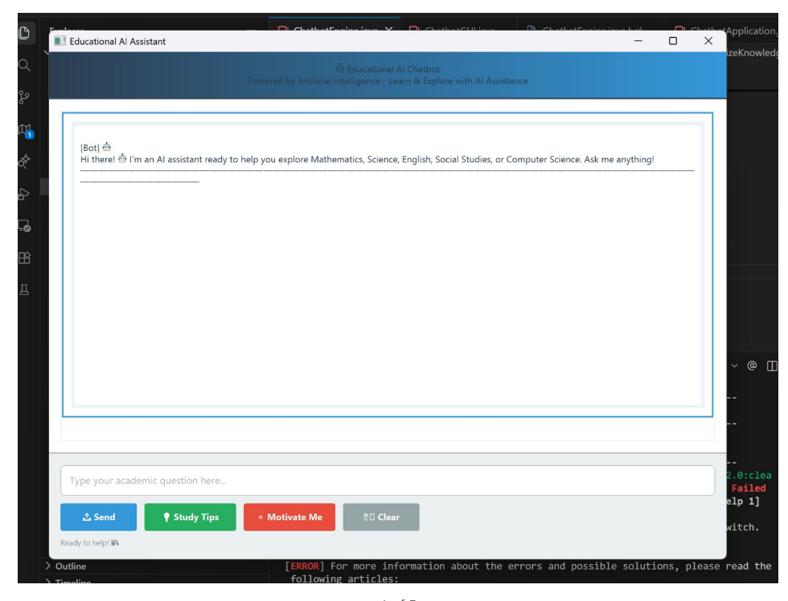
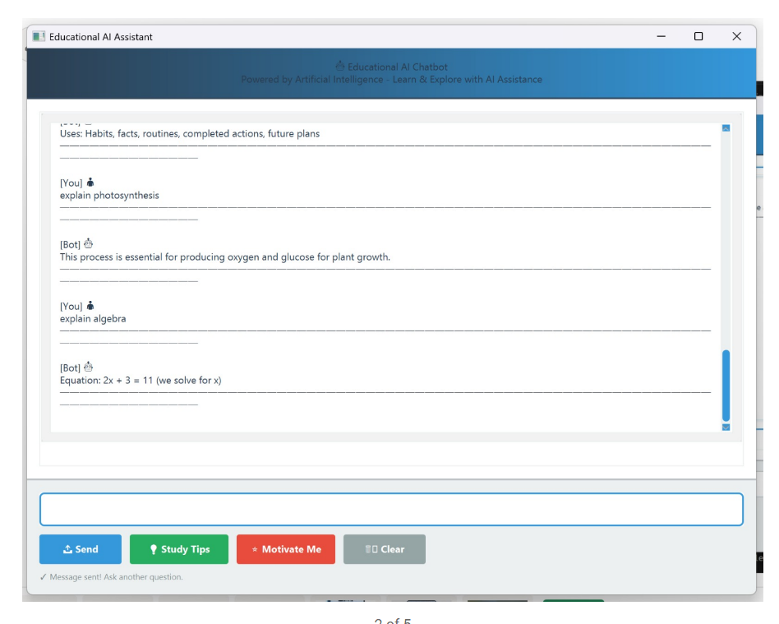
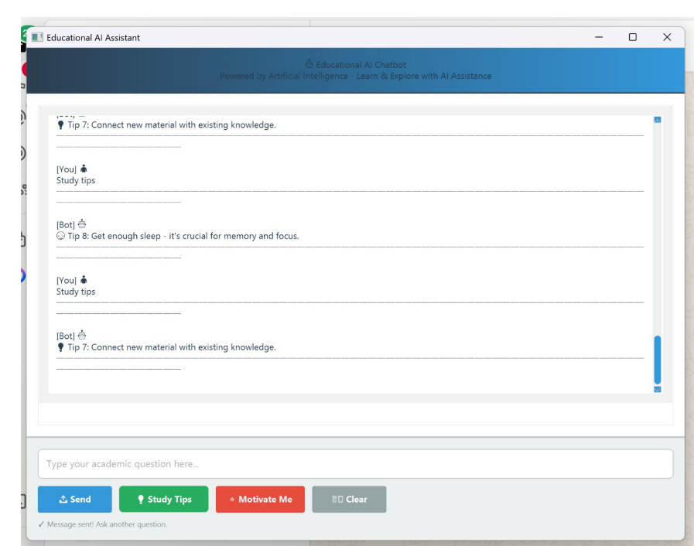
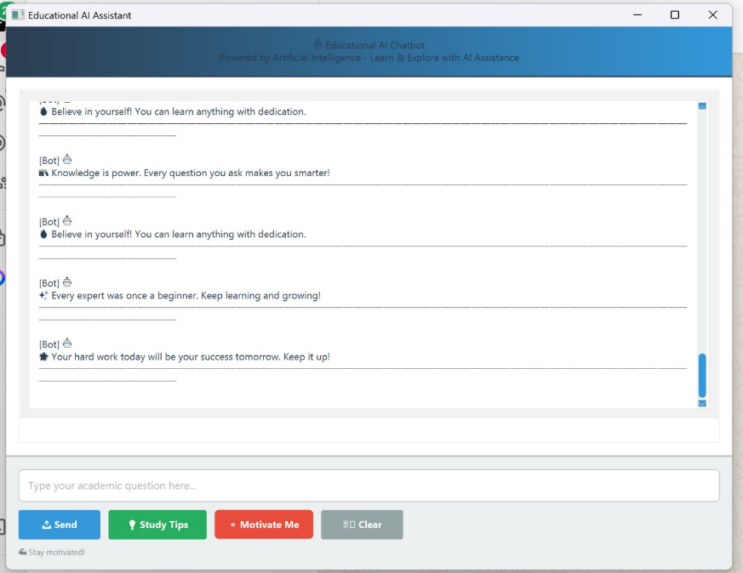
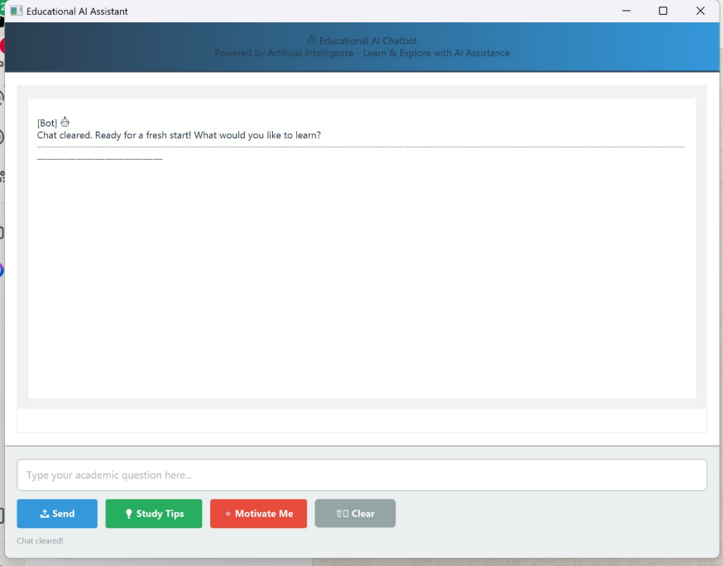

1. Chatbot Welcome Screen
When the application starts, the Educational AI Assistant window opens.
The chatbot displays a welcome message, informing the user that it can help with subjects like Mathematics, Science, English, Social Studies, and Computer Science.
This shows that the chatbot is ready to accept academic questions from the user.

2. Academic Question Answering
When the user types a question such as “explain photosynthesis”, the chatbot responds with a clear and simple explanation.
This output demonstrates that the chatbot can:
- Understand user queries
- Provide educational explanations
- Act as a virtual tutor for students

3. Multiple Subject Handling
When the user asks another question like “explain algebra”, the chatbot correctly switches topics and provides an appropriate answer.
This output shows that the chatbot supports multiple subjects and can handle different academic domains without restarting the system.

4. Motivational Responses
When the “Motivate Me” button is clicked, the chatbot displays motivational messages such as:
- “Knowledge is power.”
- “Every expert was once a beginner.”
- “Believe in yourself.”
This feature helps students stay motivated and confident, making the chatbot useful not only for learning but also for emotional encouragement.

5. Study Tips Feature
By clicking the “Study Tips” button, the chatbot provides helpful learning advice.
This output shows that the chatbot supports student self-improvement and promotes better study habits.

6. Clear Chat Function
When the “Clear” button is pressed, the entire chat history is removed, and the chatbot displays:
“Chat cleared. Ready for a fresh start! What would you like to learn?”
This output confirms that:
- The chat reset feature works correctly
- Users can start a new learning session easily

7. User-Friendly Interface
All outputs appear in a clean chat window with proper formatting.
Buttons like Send, Study Tips, Motivate Me, and Clear make the system easy to use even for beginners.

FUTURE SCOPE
The AI Chatbot for Education System has strong potential for future enhancement and expansion as technology evolves. Some key future scopes include:
- Advanced Personalization
The chatbot can be improved to understand individual learning styles, strengths, and weaknesses, and provide fully personalized study plans and recommendations.
- Integration with Learning Management Systems (LMS)
Future versions can be integrated with platforms like Moodle, Google Classroom, or Blackboard to access assignments, grades, and learning materials directly.
- Voice-Based Interaction
Adding voice input and output will allow students to interact with the chatbot using speech, making learning more accessible and user-friendly.
- Multilingual Support
The chatbot can support multiple regional and international languages, helping students from diverse backgrounds learn more effectively.
- Adaptive Learning Using AI/ML
By using machine learning, the chatbot can continuously learn from user interactions and improve the accuracy and quality of responses over time.
- Emotion and Sentiment Analysis
Future systems can detect student emotions (stress, confusion, motivation) and respond with appropriate support or encouragement.
- Assessment and Progress Tracking
The chatbot can conduct quizzes, evaluate answers, track student performance, and provide detailed feedback and analytics.
- 24/7 Virtual Academic Advisor
It can be expanded to guide students on career choices, course selection, exam preparation, and higher education opportunities.
- Enhanced Security and Privacy
Future implementations can include stronger data encryption, secure authentication, and compliance with educational data protection standards.
- Mobile App and Cloud Deployment
Deploying the chatbot as a mobile application and on cloud platforms will ensure scalability, reliability, and access anytime, anywhere.
RECOMMENDATIONS
- Improve Answer Accuracy
Integrate advanced AI models and regularly update the knowledge base to provide more accurate and reliable academic responses.
- Personalized Learning Support
Add student profiling to offer personalized study plans, subject-wise recommendations, and learning reminders based on user performance.
- Multilingual Support
Include multiple regional and international languages to make the chatbot accessible to a wider and diverse group of students.
- Voice-Based Interaction
Enable voice input and output so students can interact hands-free, improving accessibility for differently-abled users.
- Assessment and Quiz Module
Introduce quizzes, mock tests, and instant feedback to help students evaluate their understanding and track progress.
- Integration with Learning Platforms
Connect the chatbot with Learning Management Systems (LMS), online classrooms, and digital libraries for seamless learning support.
- Stronger Data Privacy and Security
Implement encryption and strict data protection policies to safeguard student information and build trust.
- Teacher and Admin Dashboard
Provide dashboards for teachers and administrators to monitor usage, common queries, and student learning trends.
- Offline and Low-Bandwidth Mode
Optimize the system to work in low-internet environments, especially beneficial for rural or remote learners.
- Continuous Feedback and Improvement
Collect regular user feedback to improve chatbot responses, usability, and overall learning effectiveness.

REFERENCES

- Labadze, L., Grigolia, M., & Machaidze, L. (2023). Role of AI Chatbots in Education: Systematic Literature Review. International Journal of Educational Technology in Higher Education, 20(56). https://doi.org/10.1186/s41239-023-00426-1
- Kingchang, T., Chatwattana, P., & Wannapiroon, P. (2024). Artificial Intelligence Chatbot Platform for Educational Recommendations in Higher Education. International Journal of Information and Education Technology (IJIET), 14(1). https://doi.org/10.18178/ijiet.2024.14.1.2021
- Davar, N. F., Dewan, M. A. A., & Zhang, X. (2025). AI Chatbots in Education: Challenges and Opportunities. Information Journal, 16(3), Article 235. https://www.mdpi.com/2078-2489/16/3/235
- Debnath, B., & Agarwal, A. (2019). A Framework to Implement AI-Integrated Chatbot in Educational Institutes. Journal of Big Data & Smart City (JBDSC), 1(1). Middle East College, Oman.
- Sandu, N., & Gide, E. (2020). Adoption of AI-Chatbots to Enhance Student Learning Experience in Higher Education in India. ResearchGate.
https://www.researchgate.net/publication/338868551
- Villanueva, D. P. P., & Aguilar-Alonso, I. (2021). A Chatbot as a Support System for Educational Institutions. 2021 International Conference on Information Technology and Management Science (ITMS), IEEE. https://doi.org/10.1109/ITMS52826.2021.9615271
- Russell, S., & Norvig, P. (2021). Artificial Intelligence: A Modern Approach (4th ed.). Pearson Education.
- Holmes, W., Bialik, M., & Fadel, C. (2019). Artificial Intelligence in Education: Promises and Implications for Teaching and Learning. Center for Curriculum Redesign.

CONCLUSION

The AI Chatbot for Education System successfully demonstrates how artificial intelligence can be used to support and enhance the learning experience for students. The developed system provides an interactive and user-friendly platform where learners can ask academic questions, receive instant explanations, access study tips, and gain motivational support. By covering subjects such as Mathematics, Science, English, Social Studies, and Computer Science, the chatbot acts as a virtual learning assistant available anytime.
The project design focuses on simplicity, efficiency, and accessibility. The graphical user interface allows easy interaction, while the AI-based response mechanism ensures quick and relevant answers. Features such as clearing chat history, motivational messages, and study guidance improve user engagement and encourage continuous learning.
This project proves that an AI-powered educational chatbot can reduce students’ dependency on traditional support systems, promote self-learning, and provide personalized assistance. With further enhancements such as advanced natural language understanding, personalization, and integration with institutional systems, the chatbot can evolve into a powerful digital tool for modern education.

